Digital Design Diploma

# **Assignment 2 [Extra]**

# **Combinational Circuit Design**

|  |  |
| --- | --- |
| **Name** | كريم حسن عاطف علي |
| **Group** | G2 |

**Submitted to: Eng. Kareem Waseem**

1. **Gray One-Hot Encoder:**

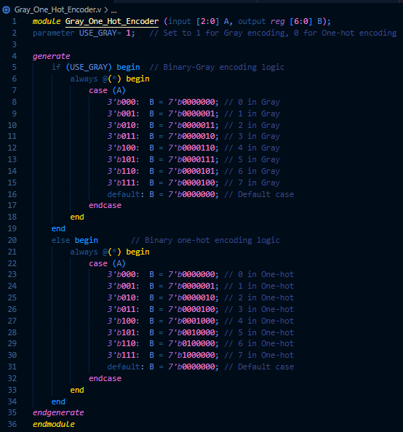

Figure 1: Q1 Code



Figure 2: Q1 Wave (Gray)



Figure 3: Q1 Wave (One-Hot)

Figure 4: Q1 Testbench (Gray)

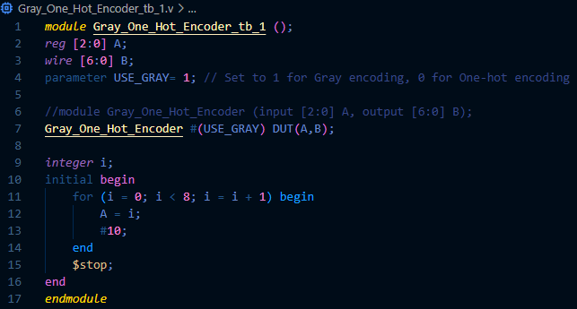

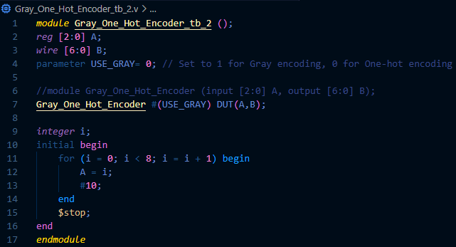

Figure 5: Q1 Testbench (One-Hot)

1. **DEMUX:**

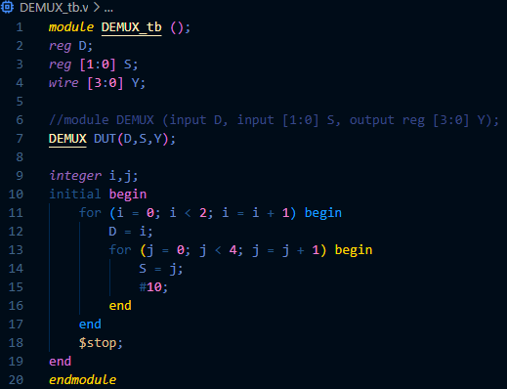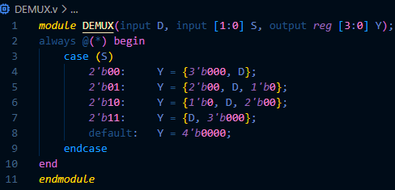

Figure 8: Q2 Wave

Figure 7: Q2 Testbench

Figure 6: Q2 Code